**Data collection**

## Before you depart check that you have:’

1. One bat detector for each sampling point
2. One ibutton for each sampling point
3. One data sheet for each sampling point
4. One three meter pipe for each sampling point
5. One iron rod for each sampling point
6. One clamp for each sampling point
7. One mallet
8. One wedged prism
9. One diametrical tape
10. One 50 mts measuring tape
11. One densitometer
12. Pencils
13. Duct tape
14. A GPS with all the sampling points
15. A detailed map of the sampling points

## Getting to the sampling points

Head to the sampling points appointed for the day using the GPS and maps, once you get to the point use the mallet to stick an iron rod on the sampling point about half way through. This will help you to remember where the point is and it will be used later on to install the bat detector.

Before putting up the detector, measurements of vegetation attributes will be measured from the sampling site; the measurements that will be taken are Canopy cover, land cover area and basal area. In the next paragraphs the sampling methods will be explained. In figure 1 a drawing of the sampling site is shown.

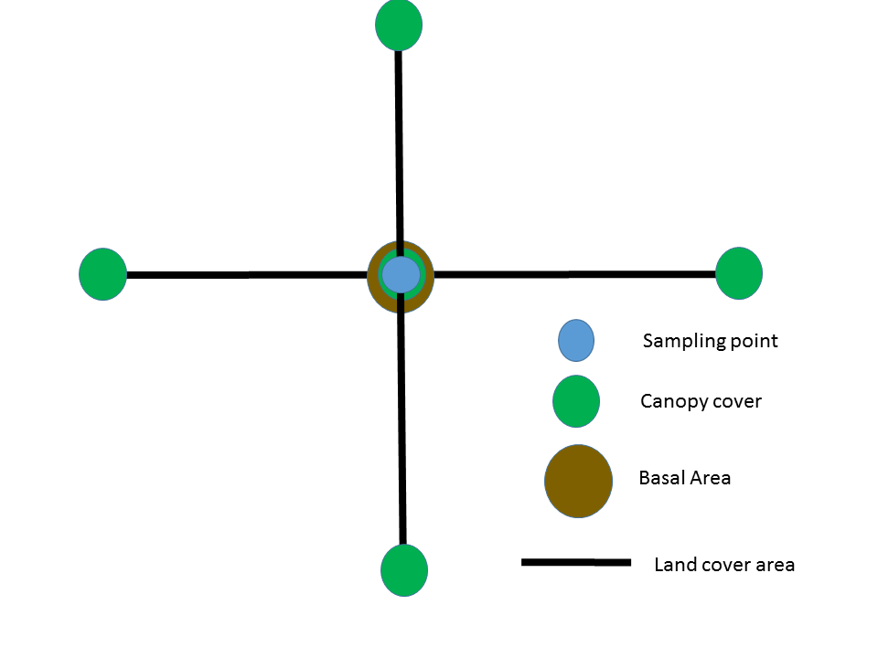

Figure drawing of the vegetation and the sampling site

**Vegetation plot**

**Canopy cover**

**Description**

*The canopy cover is the percentage of overhead sky covered with canopy. This is measured with a gridded concave densiometer. These measurements are taken at 50 meters towards each of the four cardinal points from the sampling point and at the sampling point (figure 1).*

Activity

To use the densitometer, hold the instrument at 12 to 18 inches in front of you at elbow height, use the level bubble to make sure that the densiometer is flat. If the densiometer is in the right position you should be able to see your forehead in the mirror of the densiometer but it shouldn't overlap with the grid (Figure 2), you should also see a bubble within the drawn circle .

For each one of the 24 squares in the grid imagine 4 equidistant dots and count the ones that are not in the open sky. Write down that number and repeat it for all of the 5 points in each sampling area.

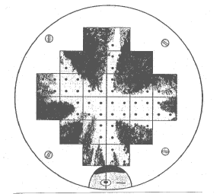

Figure Drawing of how an image should be seen in a spherical densiometer when collecting data, notice that you should see your head in the reflection, but it should not touch the grid, extracted from Standard Operating Procedure for Determining Canopy Closure using a Concave Spherical Densiometer – Model C for the Extensive Riparian Status and Trends Monitoring Program Washington state Department of Ecology

**Land cover area**

Description

Land cover area, is the percentage of land covered by each vegetation type, in order to measure this the type of vegetation of 50 plots in each cardinal point will be determined from the sampling point.

Activity

From the sampling point take the measuring tape and walk 50 meters straight with the compass

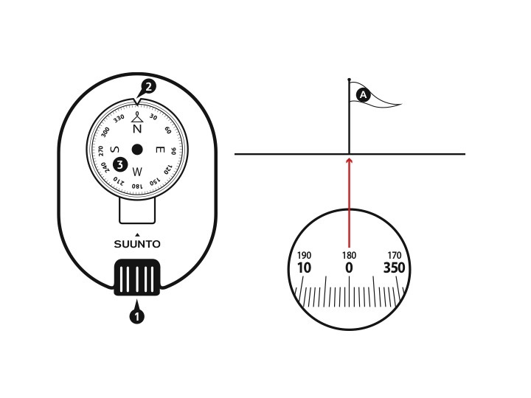

Figure Drawing of a compass showing 1 optics, 2 bearing index and 3 compass card: right, looking throught the optics, figures extracted from Suunto KB-20 compass user guide.

Use of the compass to walk a straight line towards a cardinal point.

Place the compass horizontal to the ground and point towards the cardinal point you need to walk to. Place one of your eyes on the optics (figure 3), turn around until you find the needed number to follow, if you are heading South that number will be 180, East 90, West 270, and North 0. Keeping both eyes open, use the eye you have in the optics of the compass to keep your bearing, and the other one to navigate through obstacles while you take the measuring tape to 50 meters of distance in that direction.

After that, go back looking in each meter interval. For each meter imagine a square of 1 by 1 meter and determine if the dominant land cover type as woody growth, herbaceous growth, Grass, Naked Soil, Rocky Scree, Down wood or leaf Litter.

**Basal area**

Description

Basal area is the square meters per hectare covered by the trunk of a tree within the plot, this is measured using a diametrical tape to measure the diameter of the tree, and a wedge prism to check which trees are in or out of the vegetation plot.

Activity

The first person stands in the sampling point and uses the wedge prism to check every tree starting on the north rotating in a clockwise direction in the spot.

To check weather a tree is in or out of the sampling plot, standing in the sampling point, look at a tree through the wedge prism; if the image of the tree trunk that you see in the prism overlaps with the one outside of the prism, the tree is in the vegetation plot, and it should be measured. If they don’t overlap, the tree is out of the vegetation plot and shouldn’t be measured (Figure 4).



Figure Figure showing three trees as seen through a wedge prism, in this case from left to right, the first tree is out, the second is in and the third one is questionable, extracted from Mitchell, W. A., Hughes, H. G., & Marcy, L. E. (1995). *Prism Sampling: Section 6.2. 3, US Army Corps of Engineers Wildlife Resources Management Manual*(No. WES/TR/EL-95-24). ARMY ENGINEER WATERWAYS EXPERIMENT STATION VICKSBURG MS ENVIRONMENTAL LAB.

**Using the bat detectors**

**Day 1**

**Setting the bat detector**

Open the lower case of the Petterson d500x (Figure 5) and Set the toggle to **INT**, carefully close the lower case To protect the memory cards.

In the front of the bat detector (Figure 6), press F1 and go to “RECORDING SETTINGS”, press enter, and set INPUT GAIN=80, TRIG LEV=80, INTERVAL=0, and press ENTER again.



Figure lower case of the petterson bat detector, extracted from D500X USER’S MANUAL Firmware

version 2.2.5

**Installing bat detectors**

Return the detector to the box, close it, and leave only the microphone out trying to leave the box hidden from casual visitors.

Attach the microphone to the PVC pipe in the clamp, and attach the clamp to the metal pipe, then put the metal pipe in the iron rod set in the sampling point. Attach the ibutton to the box of the detector using duct tape.

Day 4

**Retrieving the detector**

Return to the sampling point, open the box, and put the toggle in **OFF** before you do anything else. Make sure to put everything neatly in the box, and return with the detector, pipe, iron rod, clamp, ibutton and microphone.



Figure front of the pettersson dx500 bat detector extracted from D500X USER’S MANUAL Firmware version 2.2.5

**Extract the**